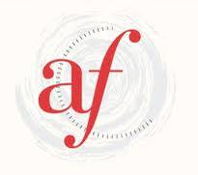

Alliance Française de Geelong
C1.8 Online (with Malika) Term 2, 2025

This course will be conducted exclusively in French and requires a confident level. It is suitable for students who have already completed approximately ten years of French study. New students should contact us via email before enrolling.

Level: C1.8

Wednesday 6.45-8.45pm

Teacher: Malika Ben Mustapha

Class dates: April 23, 30
May 7, 14, 21, 28
June 4, 11, 18, 25
July 2

11 sessions

Course: In term 2 students will study Dossier 8 ‘D’innombrables langues françaises’

The following leçons will be covered:

- Cette langue-là est une reine.
- Décoloniser la langue française
- Parler le même langage
- À voix haute

Fees:
$ 374
or $ 319 (concession: school/tertiary students, pensioners)

- Cosmopolite 5 textbook $65
- Cosmopolite 5 workbook $45

Location : This class is held online via Zoom.

Payment of fees:
Please pay class fees online at www.afgeelong.com.au using our TryBooking system before the commencement of the term. Please click on ‘Find out more’ in the ‘French Classes’ section and follow prompts to pay for the C1.8 Online (with Malika) class.

Evidence of concession status:
Students who pay the concession rate are required to provide evidence of their eligibility for this rate on the first night of classes.

