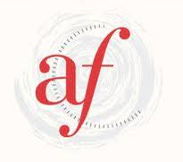

Alliance Française de Geelong

French for Travellers
Term 2, 2025

This course will be held onsite at Clonard College, Herne Hill.

CEFR level: A1.1

Monday 6.45-8.45pm

Teacher: Léa Plantevin

Class dates: April 28
May 5, 12, 19, 26
June 2, 16, 23, 30

Course: The course assumes a beginner level. The goal of the course is to equip travellers to France with language skills and cultural insights that will enhance their experience, however the course is equally valuable as a general beginner-level class. Language themes will include greetings, talking about oneself, numbers, asking questions, asking directions, weather, buying food, buying clothes and booking a hotel room. Paris, tourism in France and cultural ‘faux pas’ are some of the aspects treated in the cultural component of the course.

Costs: $34 x 9 sessions = $306
$29 x 9 sessions = $261 (school/tertiary students, pensioners)

Payment of fees: Please pay class fees online at www.afgeelong.com.au using our TryBooking system. Click on ‘Find out more’ in the ‘French Classes’ section and follow prompts for the ‘French for Travellers Term 2, 2025’ class. Students should show evidence at the start of the term if paying the concession rate.

Booklet: A booklet will be provided for this course at no further cost.

